**Fundamentals of Computer Programming**

# Building a Programming Portfolio

Week2

*You should be able to complete the following programs by the end of the week. You should keep the code somewhere safe, in an organised way. GitHub is ideal.*

*Wherever you choose, you should ensure that the work is safe and backed up.*

*Possible solutions will be uploaded to the main module GitHub repository every week. If you follow that repo you should be able to receive notifications.*

*In the following,* ***bold text*** *indicates where a user is typing.*

1. Last week you wrote a program that printed out a cheery greeting including your name. Take a copy of it, and modify it so that the user enters their name at the keyboard, and then receives a greeting. For example:

Hello, what is your name? **Mr Apricot** Hello, Mr Apricot. Good to meet you!

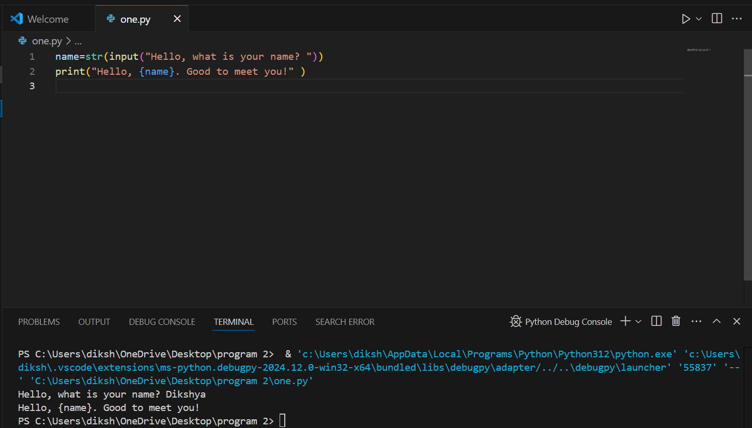

1. Write a program that prompts a user to enter a temperature in Celsius, and then displays the corresponding temperature in Fahrenheit, like so:

Enter a temperature in Celsius: **32.5** 32.5C is equivalent to 90.5F.

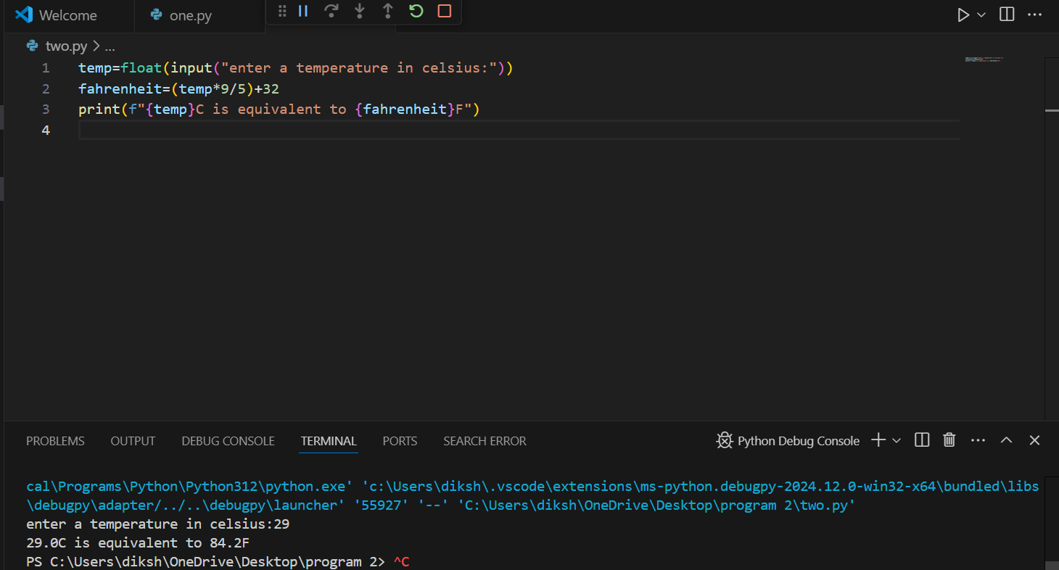

1. The Head of Computing at the University of Poppleton is tasked with dividing a group of students into lab groups. A lab group is usually 24 students, but this is sometimes varied to create groups of similar size. Write a program that prompts for the number of students and group size, and then displays how many groups will be needed and how many will be left over in a smaller group.

How many students? **113**

Required group size? **22**

There will be 5 groups with 3 students left over. For

bonus credit, see if you can fix the grammar in the output. So if there were

101 students in groups of 20 the output would be:

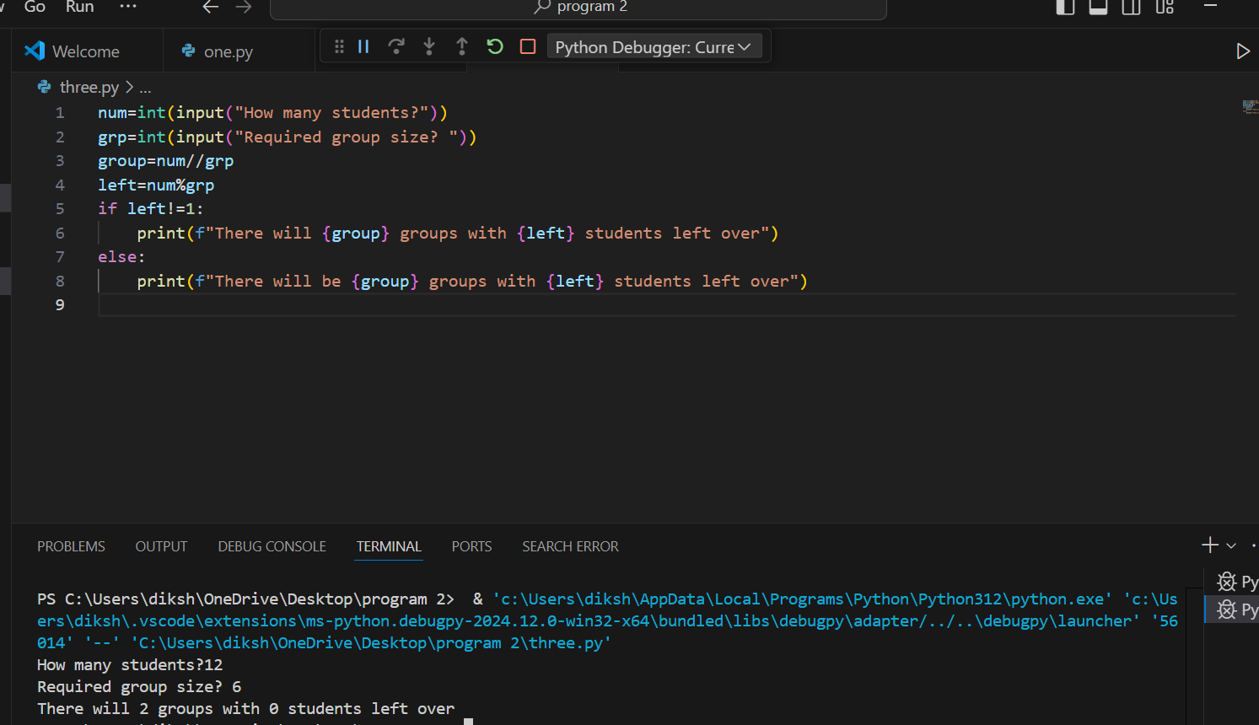

1. A kindly teacher wishes to distribute a tub of sweets between her pupils. She will first count the sweets and then divide them according to how many pupils attend that day. Write a program that will tell the teacher how many sweets to give to each pupil, and how many she will have left over.

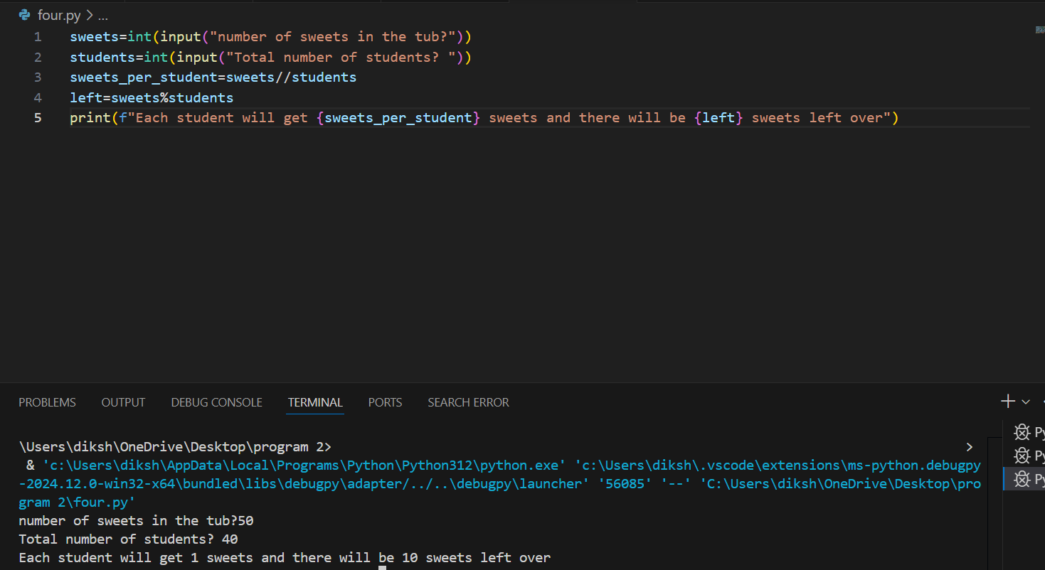

<https://dikshya-rai.github.io/program-2-FOCP/>

Programming Portfolio 02 V1.0 2022-07-25 AMJ